C/C++ BINARY SEARCH OF STRUCTURED RECORDS LAB REPORT

1) Enter your name, student ID, platform (Mac or PC) and date
Name and Student ID: Brian Quintero 0842280
Class: CIS054 C/C++ Programming
Platform (Mac or PC): Pc
Date: 4/17/2017

DESCRIPTION:
Enter and run the Binary Search of Structured Records program.

LAB REPORT:
2) Determine the Inputs, Processing and Outputs before creating the program
INPUTS | PROCESSING | OUTPUTS
typedef struct S_STATE_LIST {  char Abbreviation[3];  char StateName[15];  } States; | while (imax >= imin && !found)  {  tries++;  imid = (imin + imax) / 2;  if (_stricmp(Selection, StateList[imid].Abbreviation) == 0) // found  {  found = true;  }  // if need to go lower, change upper limit to search lower subarray  else if (_stricmp(Selection, StateList[imid].Abbreviation) < 0)  {  imax = imid - 1;  }  // if need to go higher, change lower limit to search upper subarray  else  {  imin = imid + 1;  }  } | if (found)  cout << StateList[imid].StateName << " in " << tries << " tries" << endl;  else  cout << "Not Found" << endl;  return 0;

DISCUSSION:
3) Complete the DISCUSSION section. It does not need to be long, but it needs to be complete.
3a) What did you do to develop the program? ("Followed the Directions" is not a complete description)
I set up a list of abbreviations in chronological order so the list can be read right. After that I set up the process to find the state of the the abbreviation entered, after I set up what would happen if I was not found, and what would happen If it was.

3b) What problems did you have and how did you overcome the problems?
The hardest part was setting up the midpoints and the formula to find the abbreviation that I entered.

PROGRAM OUTPUT:
4) Show screen shots for at least THREE searches: 1) search for a record at the beginning of the list, 2) search for a record anywhere in the middle of the list, 3) search for the record at the end of the list.
Refer to previous lab assignments for instructions on how to capture a screen or portions of a screen for either the PC or a Mac
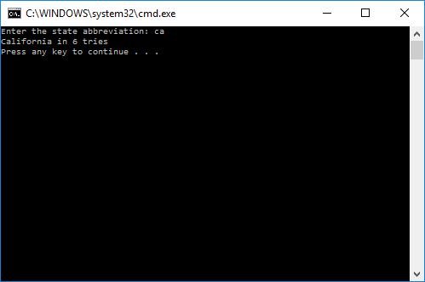
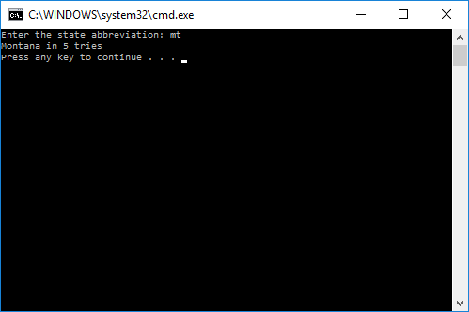
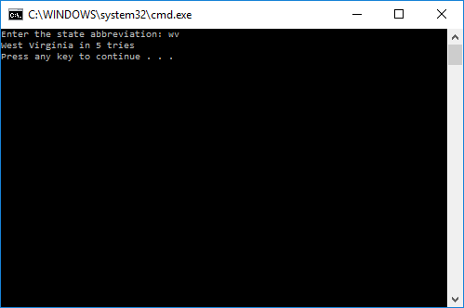

PROGRAM LISTING:
5) Copy and paste the code that YOU typed to make the program work. Your program should include a comment block at the top that shows the name of the program, date, version and your name.
// Search_Struct_Binary.cpp
//Brian quintero 0842280
//cis054 C/C++ Programming
//PC
//4/17/2017
#include "stdafx.h" // only for Microsoft Visual C++
#include <iostream>
using namespace std;

typedef struct S_STATE_LIST {
char Abbreviation[3];
char StateName[15];

} States;

States StateList[] = {
{ "AK", "Alaska" },{ "AL", "Alabama" },{ "AR", "Arkansas" },{ "AZ", "Arizona" },
{ "CA", "California" },{ "CO", "Colorado" },{ "CT", "Connecticut" },{ "DE", "Delaware" },
{ "FL", "Florida" },{ "GA", "Georgia" },{ "HI", "Hawaii" },{ "IA", "Iowa" },{ "ID", "Idaho" },
{ "IL", "Illinois" },{ "IN", "Indiana" },{ "KS", "Kansas" },{ "KY", "Kentucky" },
{ "LA", "Louisiana" },{ "MA", "Massachusetts" },{ "MD", "Maryland" },{ "ME", "Maine" },
{ "MI", "Michigan" },{ "MN", "Minnesota" },{ "MO", "Missouri" },{ "MS", "Mississippi" },
{ "MT", "Montana" },{ "NC", "North Carolina" },{ "ND", "North Dakota" },{ "NE", "Nebraska" },
{ "NH", "New Hampshire" },{ "NJ", "New Jersey" },{ "NM", "New Mexico" },{ "NV", "Nevada" },
{ "NY", "New York" },{ "OH", "Ohio" },{ "OK", "Oklahoma" },{ "OR", "Oregon" },
{ "PA", "Pennsylvania" },{ "RI", "Rhode Island" },{ "SC", "South Carolina" },
{ "SD", "South Dakota" },{ "TN", "Tennessee" },{ "TX", "Texas" },{ "UT", "Utah" },
{ "VA", "Virginia" },{ "VT", "Vermont" },{ "WA", "Washington" },{ "WI", "Wisconsin" },
{ "WV", "West Virginia" },{ "WY", "Wyoming" }
};

int main(int argc, char* argv[])
{
int length = 50;
char Selection[10];
cout << "Enter the state abbreviation: ";
cin >> Selection;

// Binary Search
int imin = 0; // start index for the current search
int imax = length - 1; // end index for the current search
int imid; // midpoint for roughly equal parts
int tries = 0; // counter to see efficency
bool found = false;

while (imax >= imin && !found)
{
tries++;
imid = (imin + imax) / 2;
if (_stricmp(Selection, StateList[imid].Abbreviation) == 0) // found
{
found = true;
}
// if need to go lower, change upper limit to search lower subarray
else if (_stricmp(Selection, StateList[imid].Abbreviation) < 0)
{
imax = imid - 1;
}
// if need to go higher, change lower limit to search upper subarray
else
{
imin = imid + 1;
}
}
if (found)
cout << StateList[imid].StateName << " in " << tries << " tries" << endl;
else
cout << "Not Found" << endl;
return 0;
}

